**Detecting an Earthquake – Make a Seismograph**

Scientists measure ***seismic waves*,** or movements in the Earth’s crust. Special machines called ***seismographs***record movement in the Earth, including earthquakes that are so low in magnitude that people cannot feel them. You can make a simple seismograph to demonstrate how this machine works.

**Aim**

To construct a working model of a seismograph.

**Equipment**

* Retort stand, boss head, and clamp
* Scissors
* Toilet paper/narrow paper
* String
* Pencil/marker
* 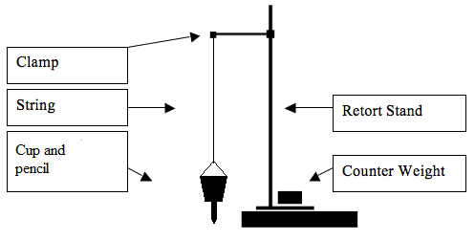Plastic or Styrofoam cup
* Masking tape or Sticky tape
* Sand/rocks/marbles
* Slotted masses

**Instructions**

1. Using the scissors, carefully poke a hole in the bottom of the cup, large enough for the marker to fit through.
2. Assemble the seismograph on a desk, according to the diagram above.
3. Lay the paper flat on the desk underneath the marker.
4. Fill the cup with sand.
5. Adjust the height of the cup/pen so the marker tip just touches the paper.
6. Test the device by having one person pulling the paper forward and a second person shaking the desk gently. Observe the markings left on the paper.
7. Move a second desk so it is touching the desk that the seismograph is on. Repeatedly bang the desk with your hand, using the same amount of force each time, while slowly pulling the paper along the desk underneath the marker.
8. Label the paper with the location and activity.
9. Repeat steps 7-8 with a new piece of paper and another activity. For example, jumping up and down next to the desk, shaking the desk, etc. You could also increase the distance from the table that you jump.

**Results:**

|  |  |  |
| --- | --- | --- |
| **Variable** | **Observation** | **Inference** |
|  |  |  |
|  |  |  |
|  |  |  |
|  |  |  |

**Questions**

1. Did your seismograph do its job (recording the movement of the ground underneath it)?   
   What evidence do you have to prove it worked?

_________________________________________________________________________________________________________________________________________________________________________________________________________________________________________________________

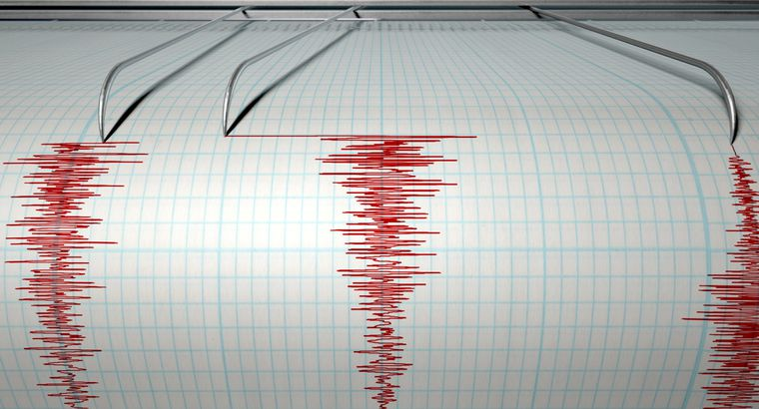

1. A seismograph makes a paper recording of an earthquake.   
   This paper record is called a __________________.
2. What does it mean when the wavy lines on the paper are bigger or smaller? How could you use that to measure an earthquake?

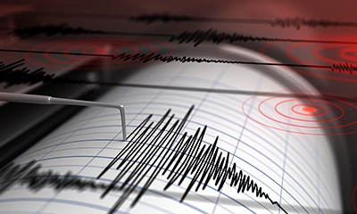___________________________________________________________________________________________________________________________________________________________________________________________________________________________________________________________________________________

1. How would you improve your seismograph if you did this project again? Why would you change it?

____________________________________________________________________________________________________________________________________________________________________________________________________________________________________________________________________________________________________________________________________________